ACHARYA NARENDRA DEV COLLEGE

(UNIVERSITY OF DELHI)

GOVINDPURI, NEW DELHI-110019



**BSc. Physics Hons. (III Semester)**

**GE Practical File:**

**DIFFERENTIAL EQUATIONS**

Submitted To:

Dr. De0 Datta Aarya

Submitted by:

Devanshi Mitra

AD-815  
21001567013

1. Solution of First Order of Differential

Equation

Example 1:

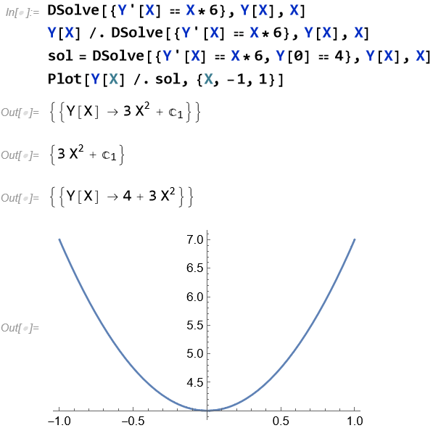

Example 2:

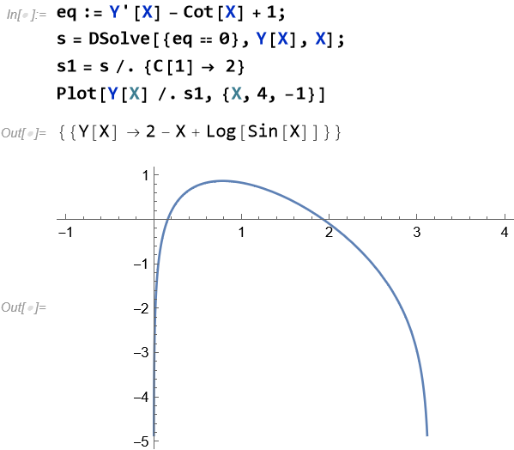

Example 3:

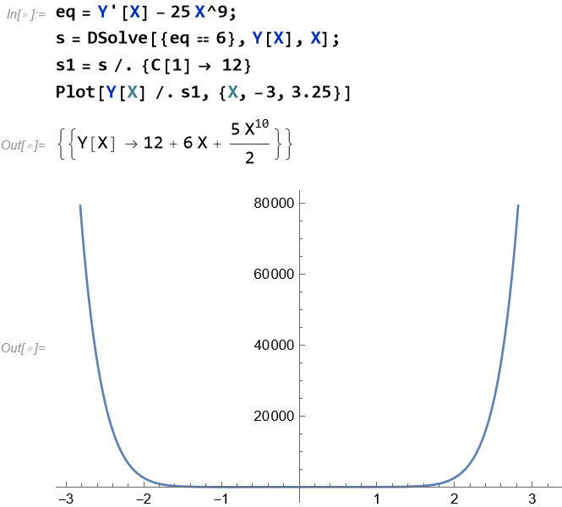

2. Plotting of Second Order Solution

Family of Differential Equation

Example 4:

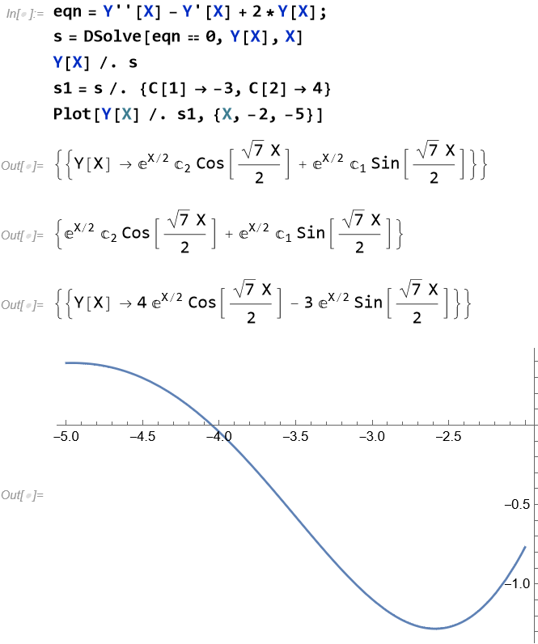

Example 5:

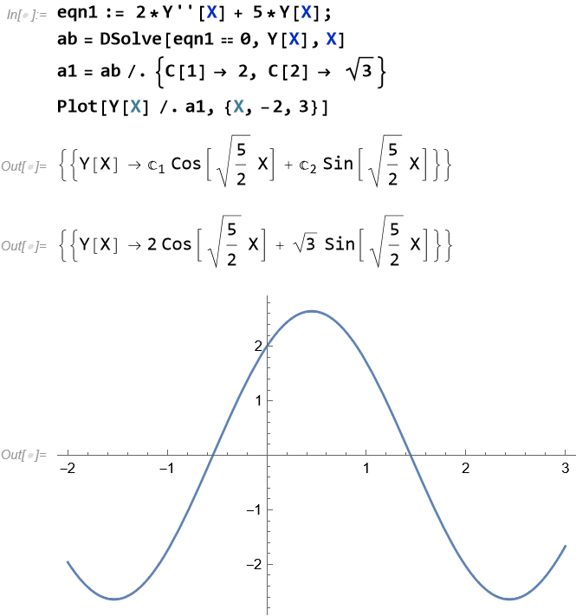

3. Plotting of Third Order Solution

Family of Differential Equation

Example 6:

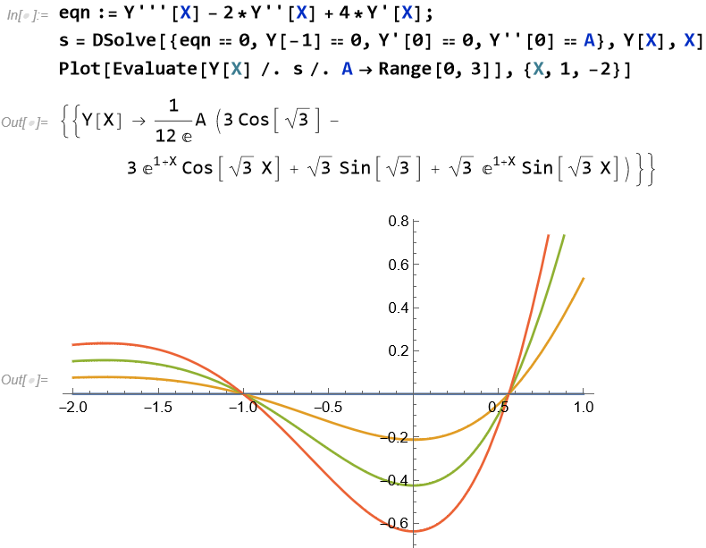

Example 7:

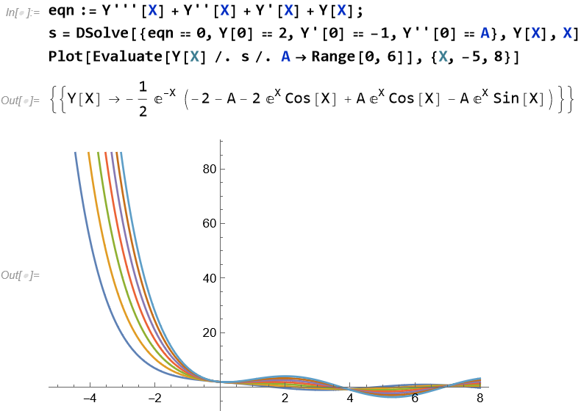

Example 8:

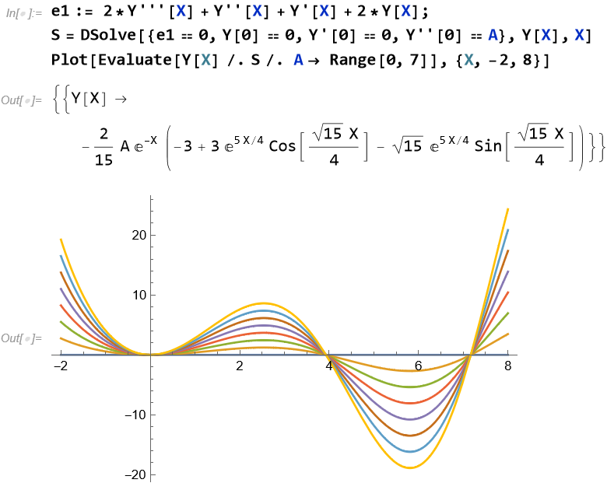

4. Solution of Differential Equation by

Variation of Parameter Method

Example 9:

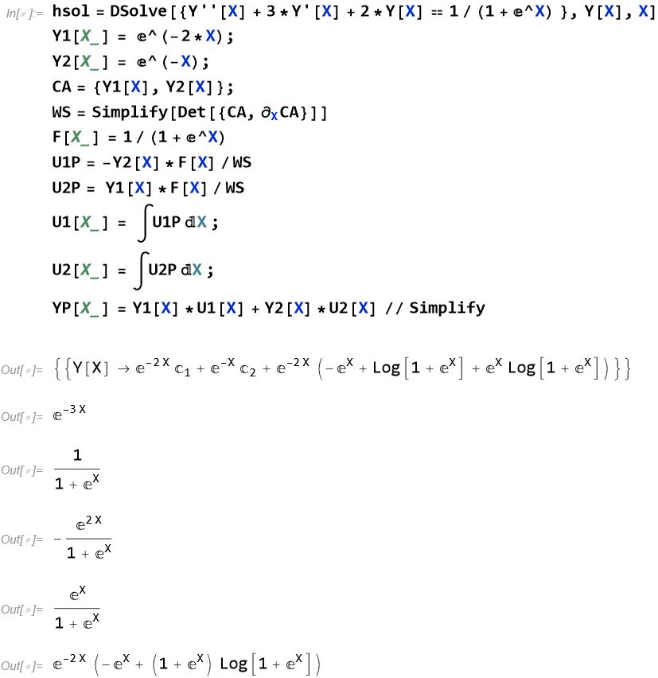

Example 10:

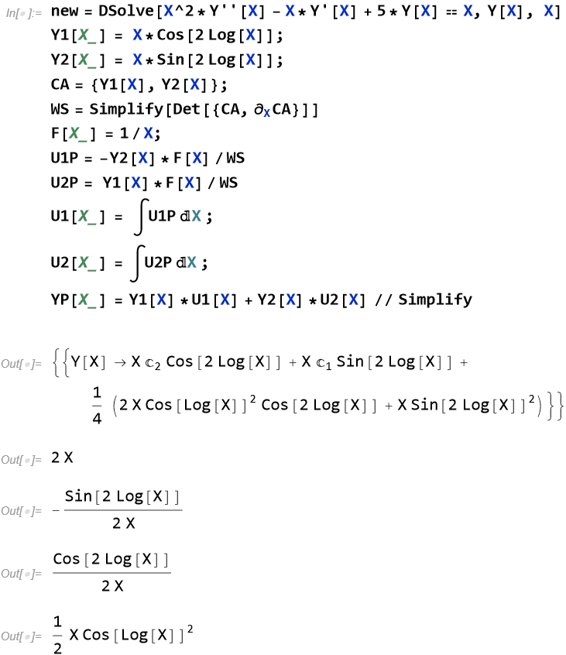

Example 11:

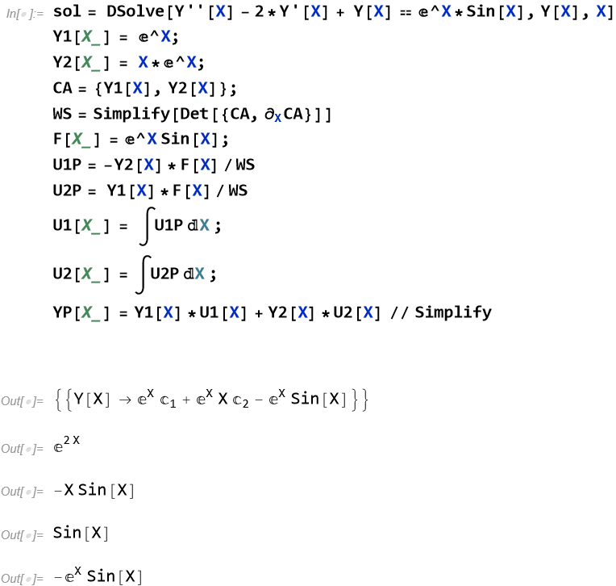

5. Solution of System of Ordinary Differential Equations

Example 12:

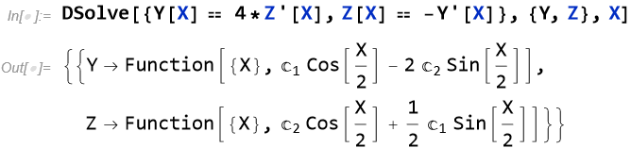

Example 13:

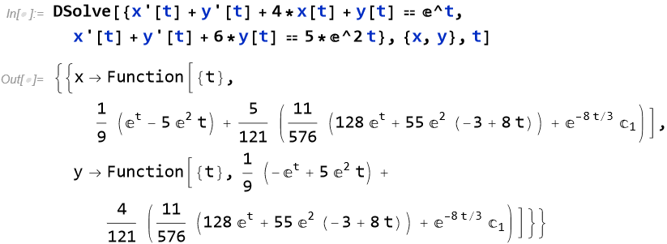

Example 14:

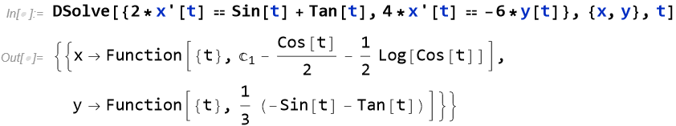

6. Solution of Cauchy problem for First

Order Partial differential Equation

Example 15:

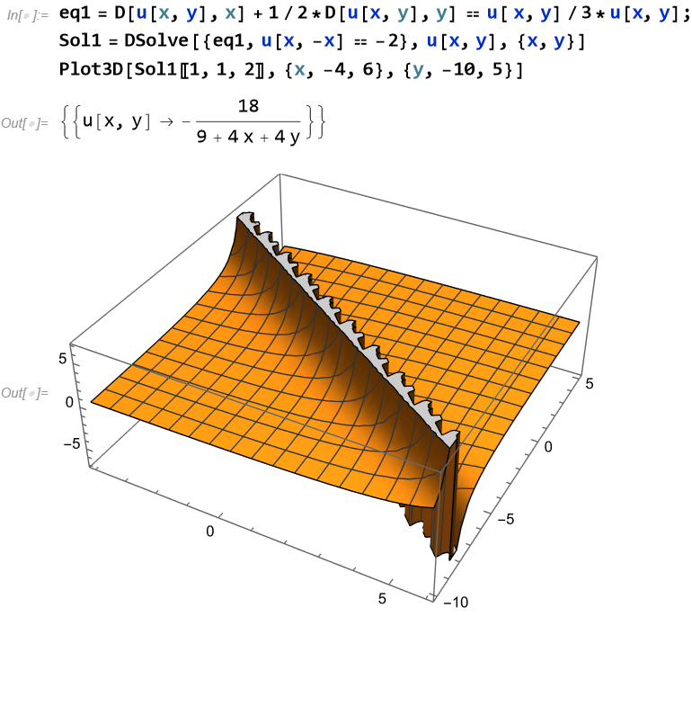

Example 16:

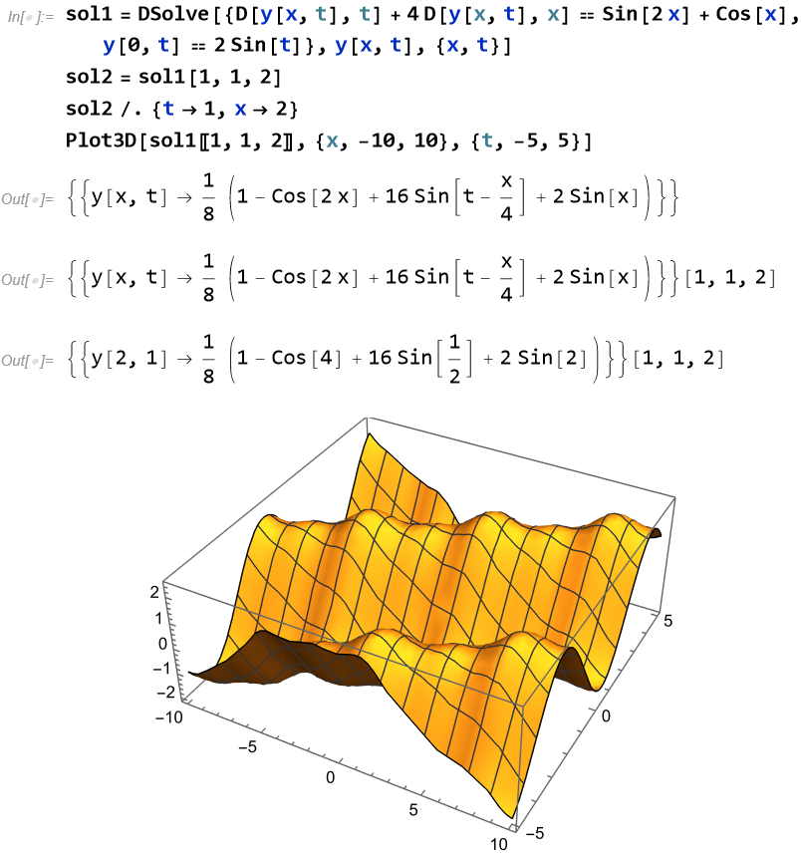

Example 17:

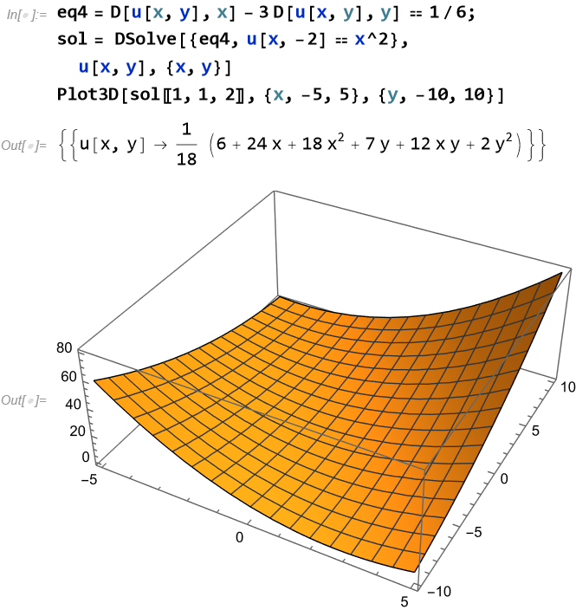

7. Plotting the Characteristics of the

First Order Partial Differential Equations

Example 18:

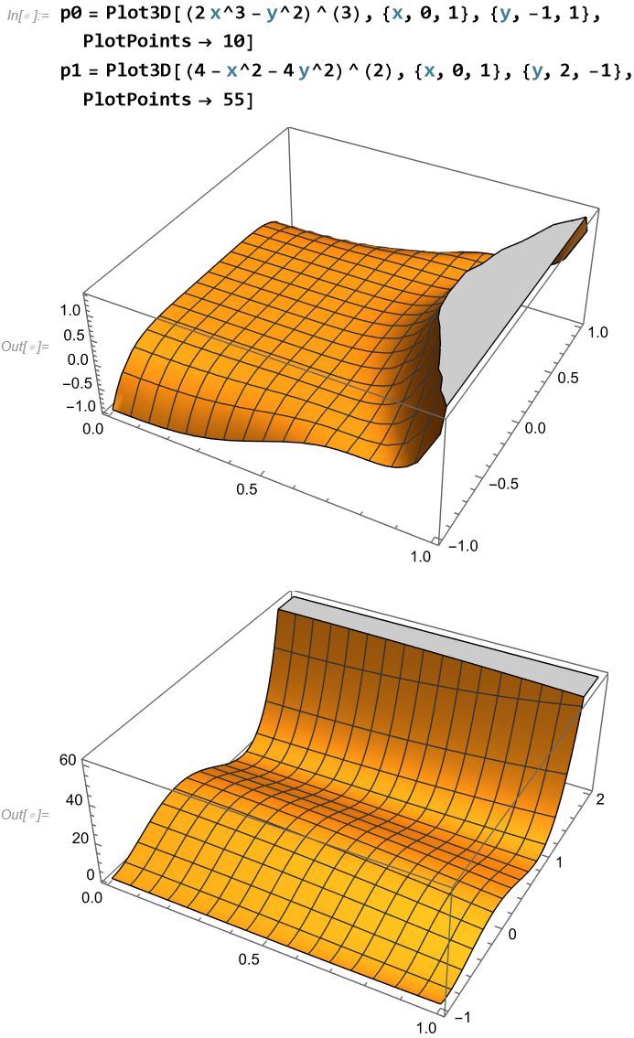

Example 19:

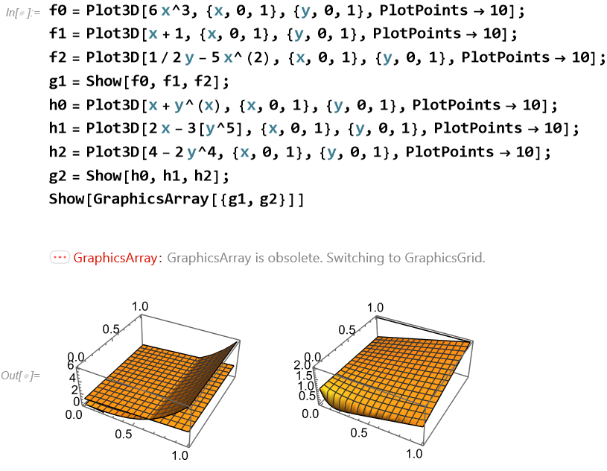

Example 20:

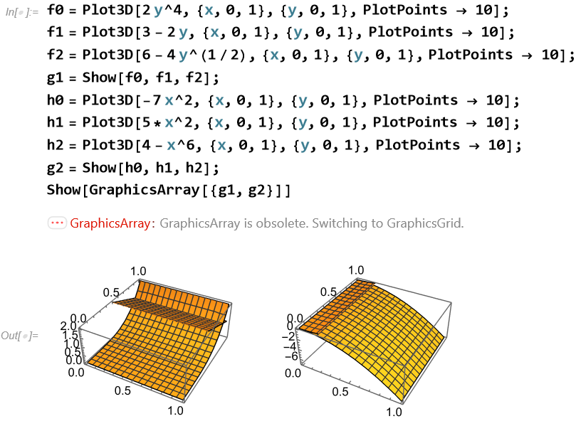

8. Plot the Integral Surfaces of First

Order Partial Differential Equations with Initial Data

Example 21:

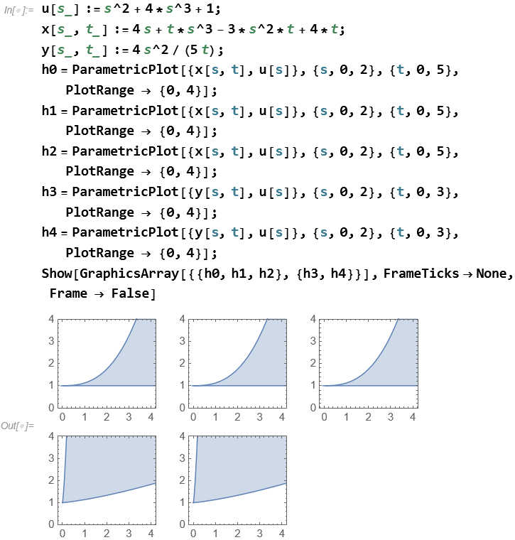

Example 22:

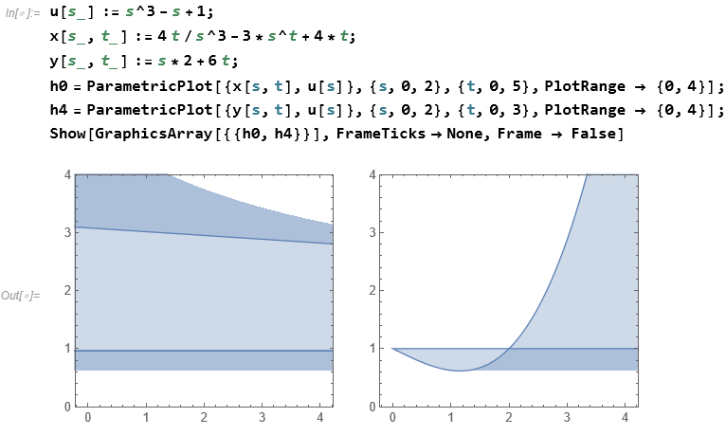

Example 23:

